PORTFOLIO 3: TRANSACTION MANAGEMENT

1. INTRODUCTION
Transaction management in a banking system uses database and software mechanisms to treat a multi-step financial operation as a single, indivisible unit of work. This approach ensures that either all steps of a transaction complete successfully or none execute.
In Kudi Trust Bank, transaction management ensures deposits, withdrawals, and fund transfers complete successfully while maintaining data integrity. If an error occurs during processing, the database can reverse any incomplete changes to prevent inconsistencies. This portfolio demonstrates the implementation of transaction management concepts using MySQL through ACID properties, COMMIT and ROLLBACK operations, transaction logging, and concurrency control

2. ACID PROPERTIES
ACID | DEFINITION | APPLICATION AT KUDI TRUST BANK
Atomicity | A transaction is executed in its entirety or not at all. If a failure occurs during execution, all changes made up to that point are rolled back. | During a fund transfer, money is deducted from one account and credited to another as a single transaction. If any step fails, the entire transaction is rolled back
Consistency | A transaction transitions the database exclusively between valid states. The schema constraints remain enforced throughout the process. | The total amount of money in the banking system remains accurate after transfers, deposits, or withdrawals.
Isolation | Concurrent transactions are prevented from observing the uncommitted work of other transactions. The current isolation level determines the degree of isolation. | Multiple customers can perform transactions simultaneously without causing incorrect account balances.
Durability | After a transaction commits, the resulting changes persist through system crashes because they are written to disk rather than retained solely in memory. | Once a transfer commits, the transaction record remains available even if the database server crashes or shuts down unexpectedly.

The ACID properties are fundamental to banking systems as they ensure reliability, accuracy, and data integrity. Within the Kudi Trust Bank database, transaction processing depends on these properties to safeguard customer funds and maintain precise financial records.

3. TRANSACTION PROCESSING

3.1 Account Transfer
SQL QUERY
START TRANSACTION;
UPDATE Accounts
SET balance = balance - 5000
WHERE account_id = 1;
UPDATE Accounts
SET balance = balance + 5000
WHERE account_id = 3;
COMMIT;

Figure 1: Account Transfer
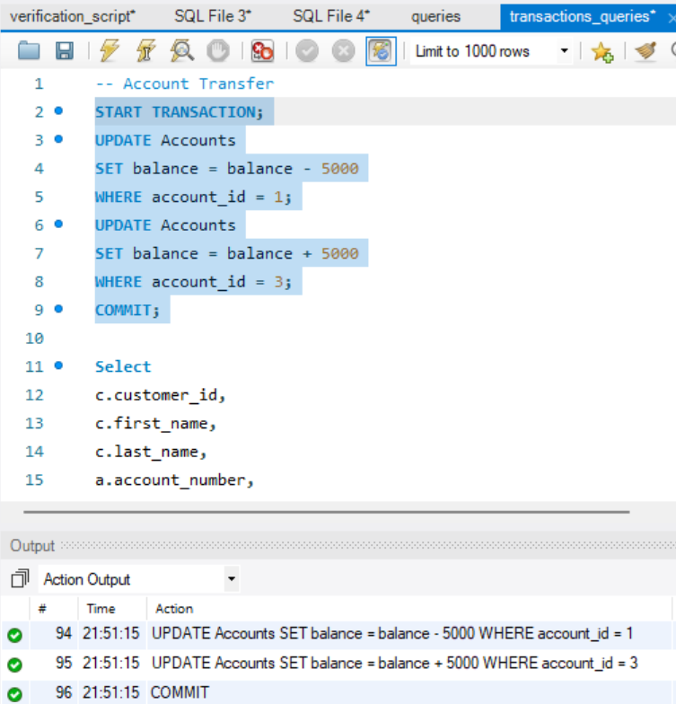
The screenshot shows a transfer transaction in which ₦5,000 was deducted from account 1 and credited to account 3. The transaction was successfully completed using the COMMIT command.
Figure 2: Updated account balance after commit.
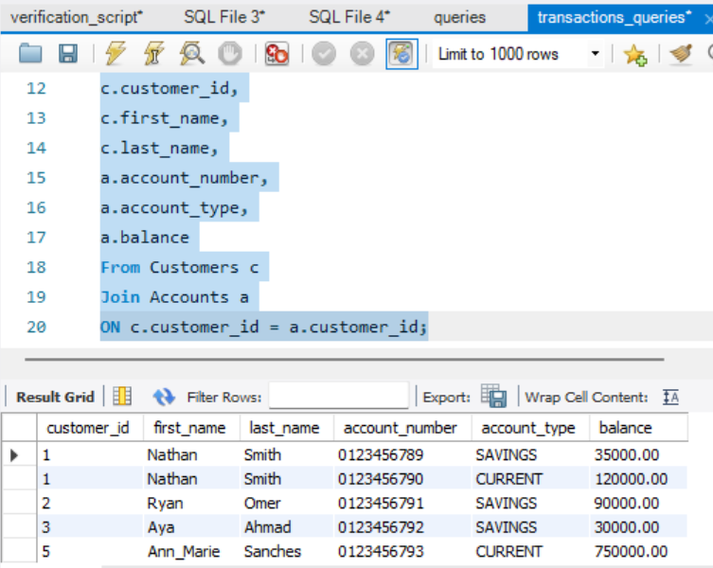
The account balances reflect the successful completion of the transfer transaction.

3.2 ROLLBACK
START TRANSACTION;
UPDATE Accounts
SET balance = balance - 10000
WHERE account_id = 1;
ROLLBACK;
Figure 3: Account balance before verification.
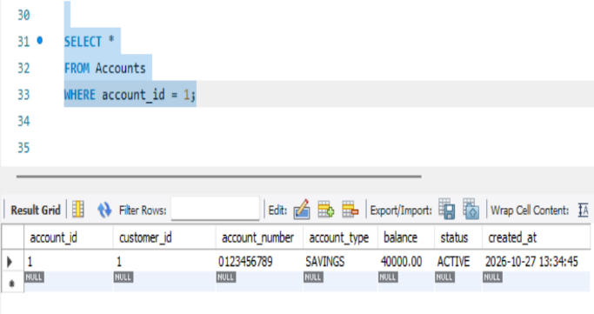
This query verified the account balance before performing rollback testing.
Figure 4: Rollback execution
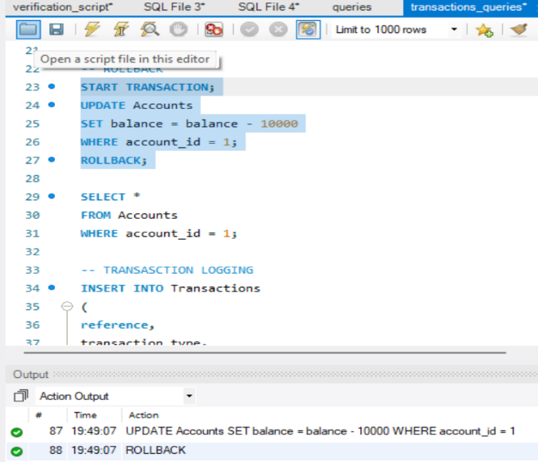`
The ROLLBACK command successfully reversed all uncommitted modifications

3.3 TRANSACTION LOGGING
Every financial activity must be recorded for auditing purposes.

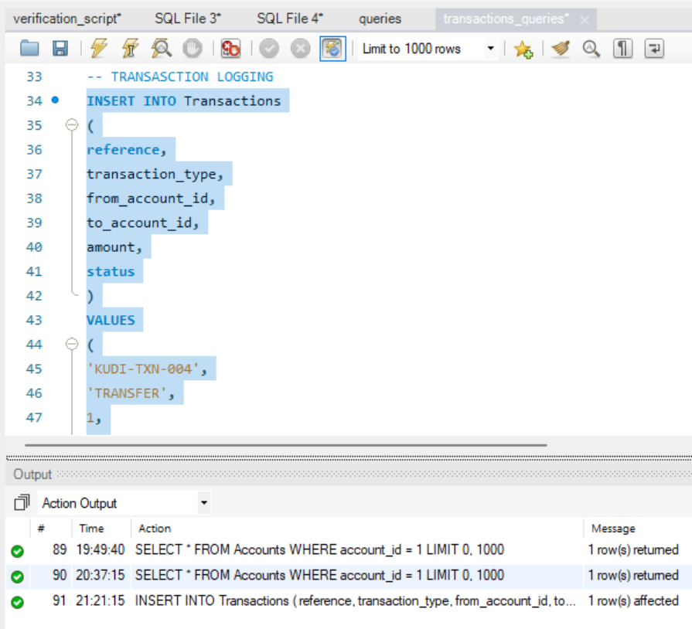

3.4 CONSISTENCY
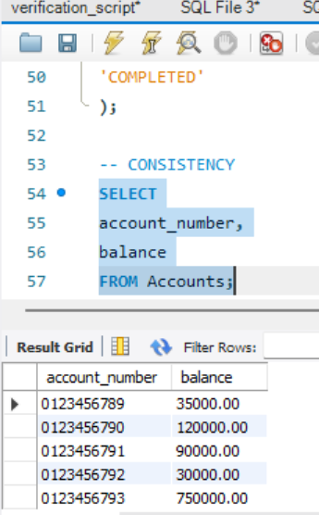

4. CONCURRENCY CONTROL
Concurrency control prevents multiple users from modifying the same account record simultaneously in a way that could cause inconsistencies. MySQL manages concurrency through locking mechanisms and transaction isolation levels, ensuring accurate banking data during concurrent operations.

5. CONCLUSION
This portfolio demonstrates transaction management techniques within the Kudi Bank database. Exploring ACID properties, executing transactions with COMMIT and ROLLBACK, and implementing transaction logging collectively maintain accountability and data integrity. These practices show how transaction management ensures reliable, secure banking operations.

